WEEK 6
TASK 6.1: STRING SIMILARITY
PROGRAM:
import java.io.*;
import java.util.*;
public class Solution {
public static long stringSimilarity(String s) {
int n = s.length();
int[] z = new int[n];
int left = 0;
int right = 0;
long sum = n;
for (int i = 1; i < n; i++) {
if (i <= right) {
z[i] = Math.min(right - i + 1, z [i - left]);
}
while (i + z[i] < n &&
s.charAt(z[i]) == s.charAt(i + z[i])) {
z[i]++;
}
if (i + z[i] - 1 > right) {
left = i;
right = i + z[i] - 1;
}
sum += z[i];
}
return sum;
}
public static void main(String[] args) throws Exception {
BufferedReader br =
new BufferedReader(new InputStreamReader(System.in));
int t = Integer.parseInt(br.readLine().trim());
while (t-- > 0) {
String s = br.readLine().trim();
System.out.println(stringSimilarity(s));
}
}
}
OUTPUT:
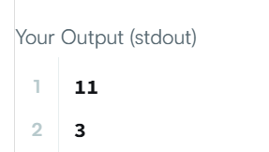

TASK 6.2:REPEATED SUBSTRING
PROGRAM:
class Solution {
public boolean repeatedSubstringPattern(String s) {

String temp = s + s;

return temp.substring(1, temp.length() - 1).contains(s);
}
}
OUTPUT:
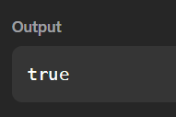

TASK 6.3:TWO STRINGS
PROGRAM:
import java.io.*;
import java.util.*;
public class Solution {
public static String twoStrings(String s1, String s2) {
boolean[] seen = new boolean[26];
for (char c : s1.toCharArray()) {
seen[c - 'a'] = true;
}
for (char c : s2.toCharArray()) {
if (seen[c - 'a']) {
return "YES";
}
}
return "NO";
}
public static void main(String[] args) throws Exception {
BufferedReader br =
new BufferedReader(new InputStreamReader(System.in));
int t = Integer.parseInt(br.readLine().trim());
while (t-- > 0) {
String s1 = br.readLine().trim();
String s2 = br.readLine().trim();

System.out.println(twoStrings(s1, s2));
}
}
}

OUTPUT:
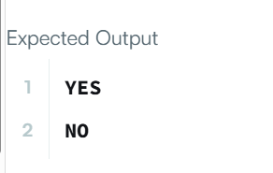

TASK 6.4:ROTATE STRING
PROGRAM:
class Solution {
public boolean rotateString(String s, String goal) {

if (s.length() != goal.length()) {
return false;
}

return (s + s).contains(goal);
}
}
OUTPUT:
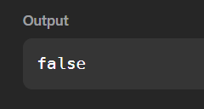

TASK 6.5:MARS EXPLORATION
PROGRAM:
import java.util.*;
public class Solution {
public static int marsExploration(String s) {
int count = 0;
String message = "SOS";
for (int i = 0; i < s.length(); i++) {
if (s.charAt(i) != message.charAt(i % 3)) {
count++;
}
}
return count;
}
public static void main(String[] args) {
Scanner sc = new Scanner(System.in);
String s = sc.nextLine();
int result = marsExploration(s);
System.out.println(result);
sc.close();
}
}
OUTPUT:
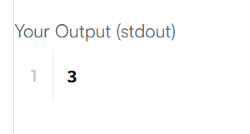

TASK 6.6: FIND ALL ANAGRAM
PROGRAM:
import java.util.*;
class Solution {
public List<Integer> findAnagrams(String s, String p) {
List<Integer> result = new ArrayList<>();
if (s.length() < p.length()) {
return result;
}
int[] count = new int[26];
for (char c : p.toCharArray()) {
count[c - 'a']++;
}
int left = 0;
int right = 0;
int required = p.length();
while (right < s.length()) {
char c = s.charAt(right);
if (count[c - 'a'] > 0) {
required--;
}
count[c - 'a']--;
right++;
if (right - left == p.length()) {
if (required == 0) {
result.add(left);
}
char leftChar = s.charAt(left);
count[leftChar - 'a']++;

if (count[leftChar - 'a'] > 0) {
required++;
}
left++;
}
}
return result;
}
}
OUTPUT:
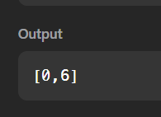

TASK 6.7:PALINDROME INDEX
PROGRAM:
import java.io.*;
import java.util.*;
public class Solution {
public static int palindromeIndex(String s) {
int left = 0;
int right = s.length() - 1;
while (left < right) {
if (s.charAt(left) != s.charAt(right)) {
if (isPalindrome(s, left + 1, right)) {
return left;
}
if (isPalindrome(s, left, right - 1)) {
return right;
}
return -1;
}
left++;
right--;
}
return -1;
}
private static boolean isPalindrome(String s, int left, int right) {
while (left < right) {
if (s.charAt(left) != s. charAt(right)) {
return false;
}
left++;
right--;
}
return true;
}
public static void main(String[] args) throws Exception {
Scanner sc = new Scanner(System.in);
int q = sc.nextInt();
while (q-- > 0) {
String s = sc.next();
System.out.println(palindromeIndex(s));
}
sc.close();
}
}
OUTPUT:
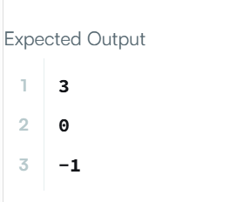

TASK 6.8:FIND THE INDEX
PROGRAM:
class Solution {
public int strStr(String haystack, String needle) {
int n = haystack.length();
int m = needle.length();
if (m > n) {
return -1;
}
for (int i = 0; i <= n - m; i++) {
int j = 0;
while (j < m && haystack.charAt(i + j) == needle.charAt(j)) {
j++;
}
if (j == m) {
return i;
}
}
return -1;
}
}
OUTPUT:
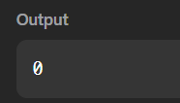

TASK 6.9:LONGEST PALINDROMIC SUBSTRING
PROGRAM:
class Solution {
public String longestPalindrome(String s) {
int start = 0;
int maxLength = 1;
for (int i = 0; i < s.length(); i++) {
int left = i;
int right = i;
while (left >= 0 && right < s.length()
&& s.charAt(left) == s.charAt(right)) {
if (right - left + 1 > maxLength) {
start = left;
maxLength = right - left + 1;
}
left--;
right++;
}

left = i;
right = i + 1;
while (left >= 0 && right < s.length()
&& s.charAt(left) == s.charAt(right)) {
if (right - left + 1 > maxLength) {
start = left;
maxLength = right - left + 1;
}
left--;
right++;
}
}
return s.substring(start, start + maxLength);
}
}
OUTPUT:
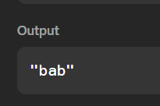

TASK 6.10:CIRCULAR PALINDROMES
PROGRAM:
import java.io.*;
import java.util.*;
public class Solution {
static int[] manacher(String s) {
int n = s.length();
StringBuilder t = new StringBuilder();
t.append('#');
for (int i = 0; i < n; i++) {
t.append(s.charAt(i));
t.append('#');
}
int m = t.length();
int[] p = new int[m];
int center = 0;
int right = 0;
for (int i = 0; i < m; i++) {
int mirror = 2 * center - i;
if (i < right) {
p[i] = Math.min(right - i, p[mirror]);
}
while (i + p[i] + 1 < m &&
i - p[i] - 1 >= 0 &&
t.charAt(i + p[i] + 1)
== t.charAt(i - p[i] - 1)) {
p[i]++;
}
if (i + p[i] > right) {
center = i;
right = i + p[i];
}
}
return p;
}
static int longestPalindrome(String s) {
if (s.length() == 0) {
return 0;
}
int[] p = manacher(s);
int maximum = 0;
for (int i = 0; i < p.length; i++) {
if (p[i] > maximum) {
maximum = p[i];
}
}
return maximum;
}
public static List<Integer> circularPalindromes(String s) {
int n = s.length();
List<Integer> result = new ArrayList<Integer>();
String current = s;
for (int rotation = 0; rotation < n; rotation++) {
int maximum = longestPalindrome(current);
result.add(maximum);
current = current.substring(1)
+ current.charAt(0);
}
return result;
}

public static void main(String[] args) throws Exception {
BufferedReader br =
new BufferedReader(
new InputStreamReader(System.in)
);
int n = Integer.parseInt(br.readLine().trim());
String s = br.readLine().trim();
List<Integer> answer =
circularPalindromes(s);
StringBuilder output =
new StringBuilder();
for (int i = 0; i < answer.size(); i++) {
output.append(answer.get(i));
if (i < answer.size() - 1) {
output.append('\n');
}
}
System.out.print(output.toString());
}
}
OUTPUT:
